AI-POWERED DIABATESE PREDICTION SYSTEM

PHASE 1 DOCUMENT SUBMISSION

NAME: D.DEEPIKA

PROJECT: Chatbot using Python

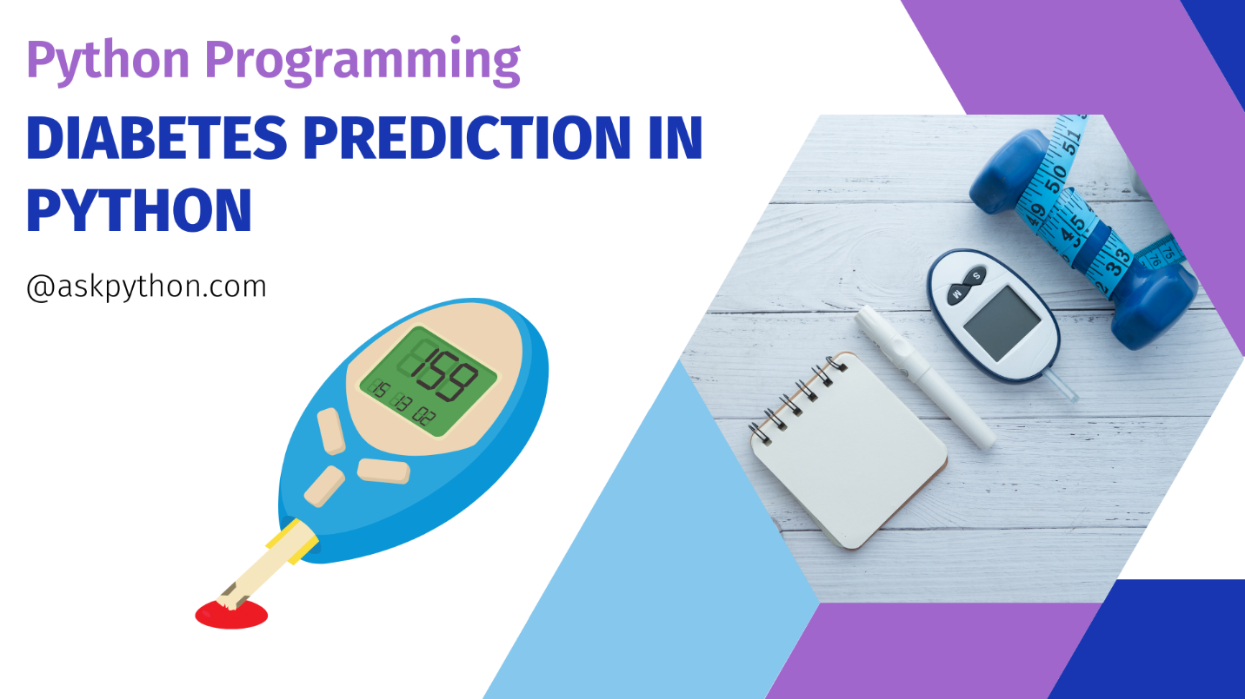

ABSTRACT:



FUNCTIONALITY:

In an AI diabetes system implemented as a chatbot in Python, the functionality can be defined to cover a range of capabilities related to diabetes management and support. Here's an overview of the scope of the chatbot's abilities:

1. **Answering Common Questions:**
   * The chatbot should be able to provide answers to common questions related to diabetes. These questions may include:
     + What is diabetes?
     + What are the different types of diabetes (Type 1, Type 2, gestational, etc.)?
     + What are the common symptoms of diabetes?
     + How is diabetes diagnosed?
     + What are the risk factors for diabetes?
     + What is the importance of blood glucose monitoring?
2. **Providing Guidance:**
   * The chatbot should offer guidance on managing diabetes effectively. This guidance can cover various aspects, such as:
     + Dietary recommendations for people with diabetes, including meal planning and carbohydrate counting.
     + Information on physical activity and its impact on blood sugar levels.
     + Medication management and insulin administration.
     + Tips for preventing complications associated with diabetes.
     + Stress management techniques and their relevance to diabetes management.
3. **Monitoring and Tracking:**
   * The chatbot can assist users in tracking their blood sugar levels, medications, and lifestyle choices. It can provide recommendations based on the user's input and trends over time.
4. **Alerts and Reminders:**
   * Implement alerts and reminders for medication schedules, regular check-ups, and important appointments with healthcare professionals.
5. **Nutritional Information:**
   * Provide nutritional information for various foods and help users make informed choices when planning meals.
6. **Interactive Features:**
   * Allow users to input their daily blood glucose readings, exercise routines, and food intake for analysis and feedback.

USER INTERFACE:

The chatbot can be integrated into a website as a widget that appears in a corner or along the bottom of the screen. It should be easily accessible but not intrusive.

1.Use on boarding and simple and clean design

2.User friendly navigation

3.Conservational interface

4.voice and text input

5.data visualization

NATURAL LANGUAGE PROCESSING:

In an AI-based diabetes prediction system, implementing natural language processing (NLP) techniques can enhance the chatbot's ability to understand and process user input in a conversational manner. NLP enables the system to comprehend and respond to text-based queries, making interactions more user-friendly. Here's how you can implement NLP in your diabetes prediction system

1.User professionalism

2.multimedia input handling

3.preprocessing and cleaning

4.sentiment analyse

5.preprocessing

6.entity recognition

7.knowledge based integration

RESPONSES:

In an AI-based diabetes prediction system, the chatbot should be able to provide accurate answers, helpful suggestions, and assistance to users seeking information about diabetes risk prediction. Here are some planned responses that the chatbot can offer:

1.resource sharing

2.continuous learning and improvement

3. **Risk Assessment Queries**

4. **Information on Diabetes Types**

**5. Personalized Risk Prediction**

**6.clarification and further questions**

**INTEGRATION:** **The integration of the chatbot into a website or app for an AI-based diabetes prediction system should be seamless and user-friendly. Here's how you can decide on the integration approach:**

**1.Smart devices and wearables**

**2. health insurance portal**

**3.social media platform**

**4.pharmacy websites**

**5.website integration**

**6.mobile app integration**

**TESTING PHASE:**

**Th testing phase include the following functionalities:**

**1.functional testing**

**2.useability testing**

**3.integration testing**

**4.performance testing**

**5.security and privacy testing**

**IMPROVEMENT STRATERGIES:**

**Testing and Improvement: Continuously test and refine the chatbot's performance based on user interactions**

**1.User feedback analysis**

**2.data collection and analysis**

**3.regular maintenance**

**4.knowledge based improvements**

**5.A/B testing**

**6.user education**

**CONCLUSION:**

**The AI-powered diabetes prediction system, presented in this abstract, offers a comprehensive and effective approach to predict the likelihood of an individual developing diabetes. By integrating data collection, preprocessing, feature engineering, machine learning algorithms, and user-friendly deployment, it represents a valuable tool in the proactive management of diabetes, ultimately contributing to improved patient outcomes and healthcare efficiency.**